22. DNS server failure
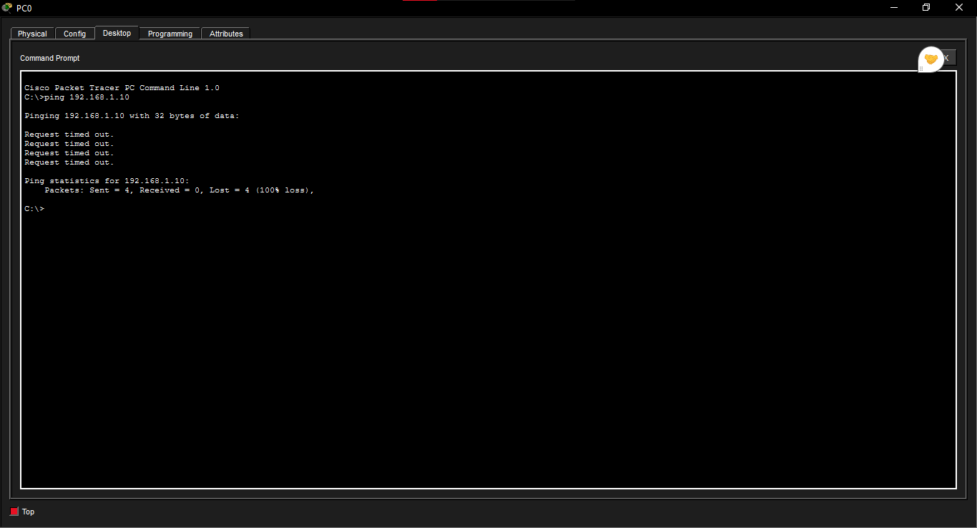

22. Physical layer Red links
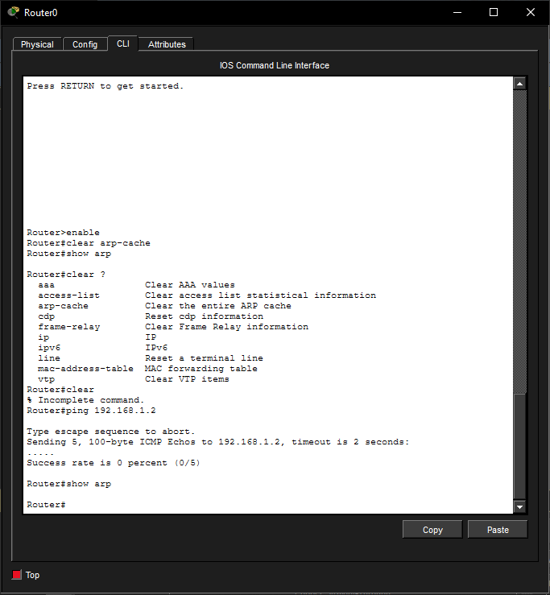

23. Data layer Missing MAC entries

Network layer No addressing
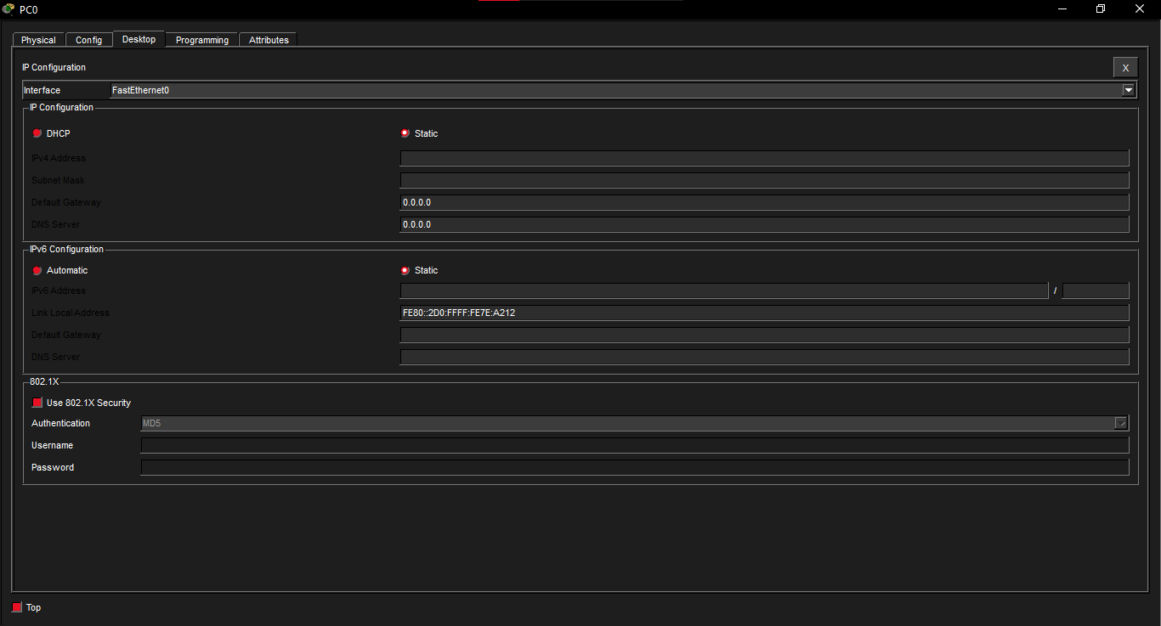

Transport layer DNS unavailable

